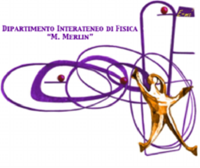
Workshop
Towards a sustainability process forGEOSS Essential Variables (EVs)
Dates: 11-12 June 2015, Bari (Italy)
Place: Dipartimento Interateneo di Fisica
Via G. Amendola 173 - 70126 Bari
http://www.connectingeo.net/Events.htm
Registration Form
Last name *

First name *

Title

E-Mail *

Institute (or project) *

Address

GEO-Societal Benefit Area (if applicable)¹
For transportation purposes, please indicate the hotel you have booked
Date of arrival
Date of Departure
Vegetarian (Y/N)
¹ Agriculture, Biodiversity, Climate (& carbon cycle), Ecosystems, Energy, Disasters, Health, Water, Weather
Please, send the form to: biagi@ba.issia.cnr.it and blonda@ba.issia.cnr.it

